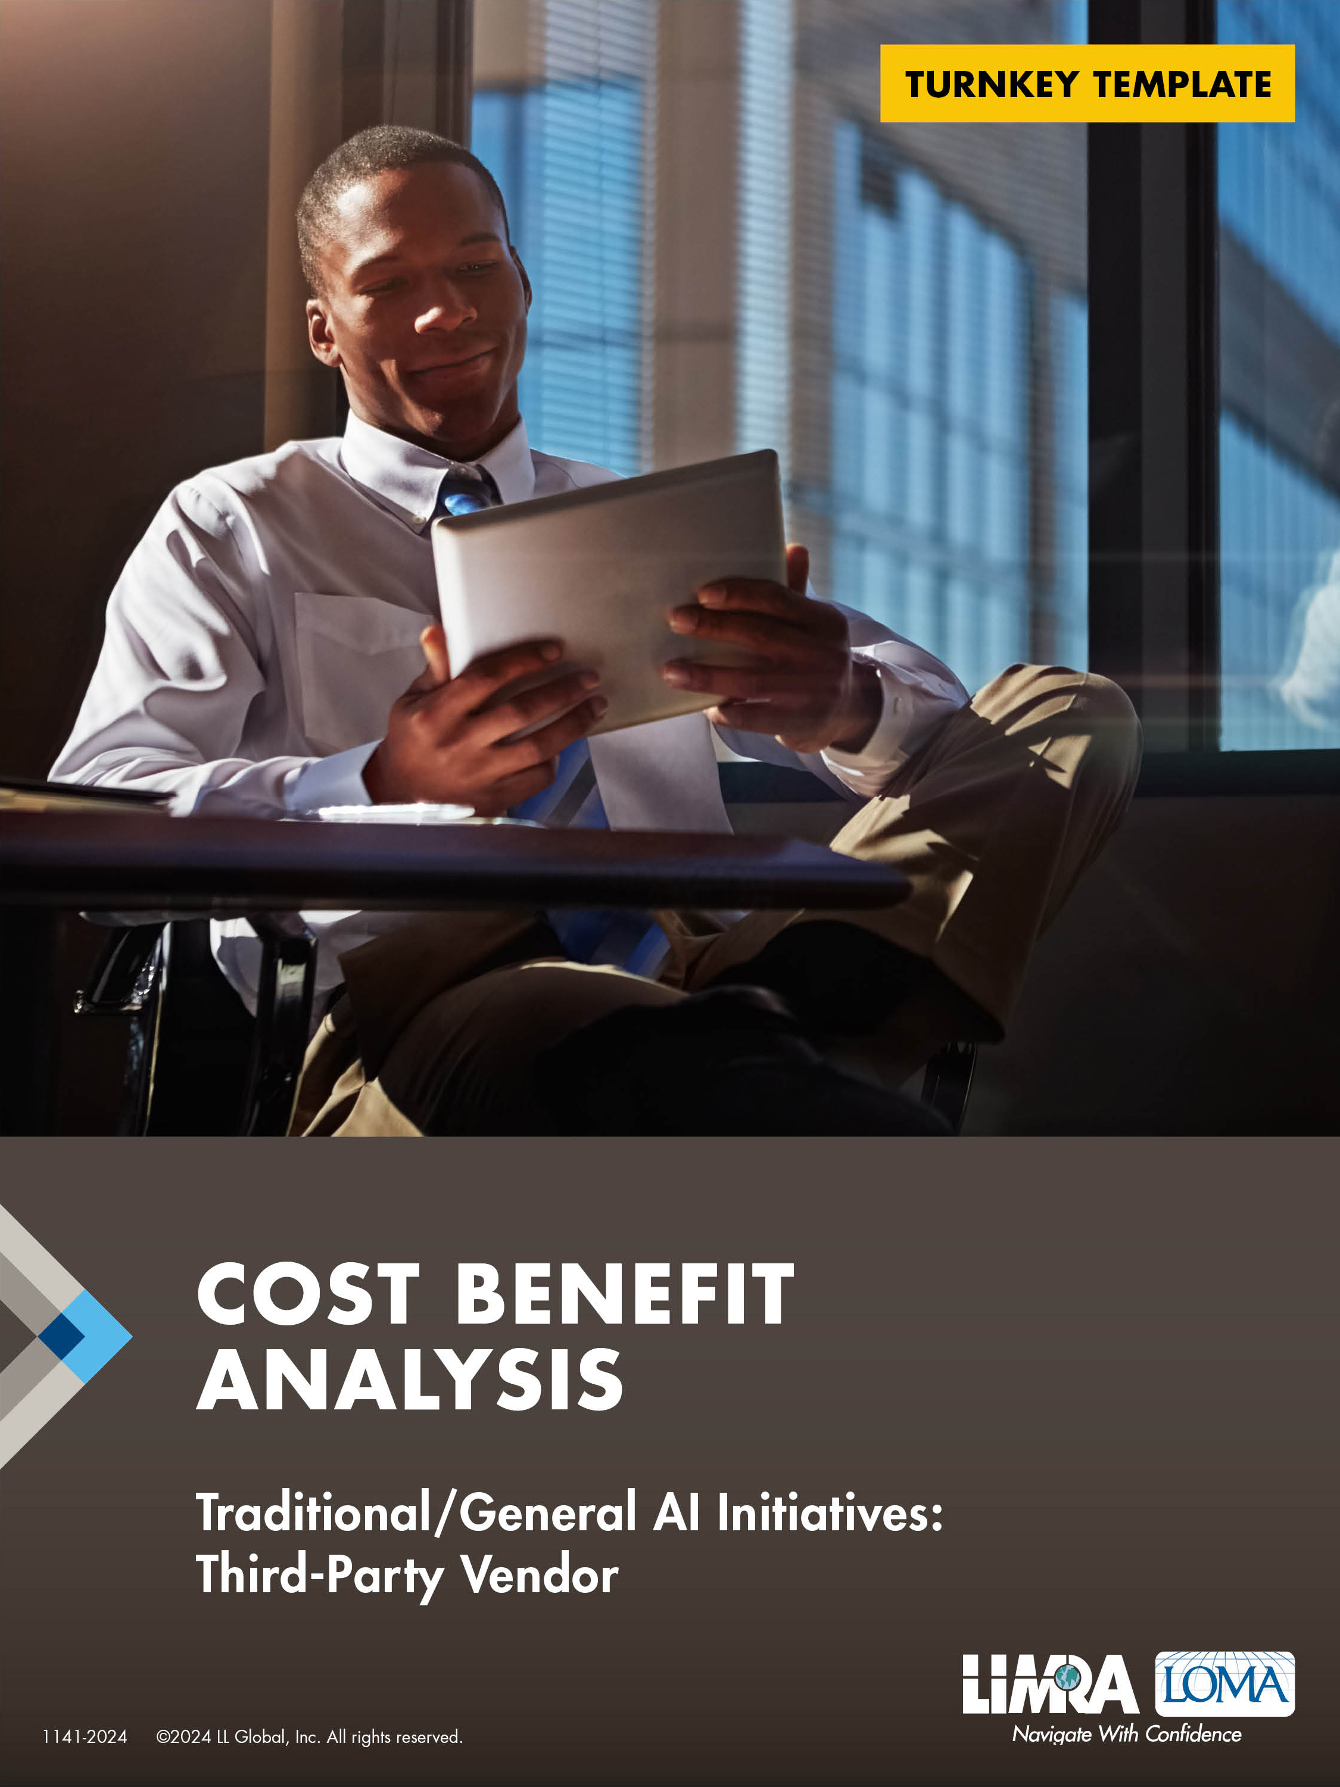

**For Additional Information:**

**Kartik Sakthivel, Ph.D., MS-IT/MS-CS, MBA, PGC-IQ**  
Vice President & Chief Information Officer   
LIMRA and LOMA  
[ksakthivel@limra.com](mailto:ksakthivel@limra.com)

*The frameworks and best practices provided herein are for general informational purposes and intended solely as guidelines to assist users in enhancing their AI strategies. These materials should not be construed as legal or financial advice or interpreted as setting a standard of care.  Users are encouraged to exercise their own discretion and judgment when applying these frameworks and best practices to their specific circumstances. While LL Global, Inc. (LIMRA and LOMA) strives to ensure the accuracy and completeness of the guidelines, LLG makes no guarantees regarding their effectiveness. Any reliance that users place on such materials is strictly at their own risk. Users are encouraged to consult with relevant professionals or experts before making any decisions based on these guidelines.*

# Overview

|  |  |
| --- | --- |
| **Date:** | <Enter submission date> |
| **Project Name:** | <Insert name of the project/initiative here> |
| **Project Code:** | <Provide an enterprise project code as appropriate> |
| **Lead:** | <Provide one Point of Contact/Project Manager/Program Manager/Scrum Master/Release Train Manager/Chief Scrum Master> |
| **Executive Summary:** | <Executive summary of the initiative. Remember to insert synopsis of final recommendations here> |
| **Executive Sponsor/s:** | <List of executive sponsors of the project/initiative> |
| **Description:** | <Provide a summary of the project> |

# 2.0 Expected Benefits

**Objective 1:** <Clearly define objectives (for ex: increase customer engagement, increase productivity, reduce content creation time, etc.)>

| Goal a: | <Clearly define measurable goals for each objective (for ex: increase customer engagement by x%, increase productivity by x%, reduce content creation time by x%)> |
| --- | --- |
| Goal b: |  |
| Goal c: |  |
| Goal n: |  |

**Objective 2:** <Clearly define objectives (for ex: increase customer engagement, increase productivity, reduce content creation time, etc.)>

|  |  |
| --- | --- |
| Goal a: | <Clearly define measurable goals for each objective (for ex: increase customer engagement by x%, increase productivity by x%, reduce content creation time by x%)> |
| Goal b: |  |
| Goal c: |  |
| Goal n: |  |

**Objective 3:** <Clearly define objectives (for ex: increase customer engagement, increase productivity, reduce content creation time, etc.)>

|  |  |
| --- | --- |
| Goal a: | <Clearly define measurable goals for each objective (for ex: increase customer engagement by x%, increase productivity by x%, reduce content creation time by x%)> |
| Goal b: |  |
| Goal c: |  |
| Goal n: |  |

**Objective n:** <Clearly define objectives (for ex: increase customer engagement, increase productivity, reduce content creation time, etc.)>

|  |  |
| --- | --- |
| Goal a: | <Clearly define measurable goals for each objective (for ex: increase customer engagement by x%, increase productivity by x%, reduce content creation time by x%)> |
| Goal b: |  |
| Goal c: |  |
| Goal n: |  |

# 3.0 Expected Costs

## 3.1 DIRECT COSTS:

### 3.1.1 Initial Investments:

|  |  |
| --- | --- |
| Software as a Service (SaaS) Licensing Third-Party Initial Vendor Fees: | <Startup licensing costs with the third-party vendor> |
| Implementation Consultant/s Costs: | <Third-party vendor or partner consulting fees> |
| Additional Data Acquisition Costs: | <Costs associated with procuring additional third-party data sets to provide to vendor> |
| Internal Data Preparation and Management Costs: | <Costs related to preparing enterprise data — if applicable — to be sent to external third-party AI vendor (for ex: collection and preparation of applicant data for automated/accelerated underwriting)> |
| Internal Infrastructure Costs: | <Internal infrastructure costs such as hardware, cloud services, and other infrastructure required to support new initiative> |
| Personnel Costs: | <Costs related to hiring employees to work with the third-party vendor and manage the new AI solution> |
| Integration Costs: | <Costs to integrate vendor AI output with internal ecosystem/other systems — provide an aggregate cost of any associated projects that deal with remediation of existing systems to interoperate/integrate with the third-party AI solution> |
| Additional Costs a: | <Additional direct costs incurred by your organization> |
| Additional Costs b: | <Additional direct costs incurred by your organization> |
| Additional Costs n: | <Additional direct costs incurred by your organization> |
| **a. SUBTOTAL OF INITIAL COSTS:** | **$** |

### 3.1.2 Operationalization Costs (Implementation):

|  |  |
| --- | --- |
| Investment in Business Process Changes: | <One-time costs across the value chain, quantified in terms of FTE costs, that would be required to support reimagining or recreating business processes> |
| Change Management: | <One-time costs across the value chain, quantified in terms of FTE costs, that would be associated with enterprise change management to effectuate a cultural change by the use of the new third-party vendor AI solution> |
| Risk Management: | <Audit and compliance costs, quantified in terms of FTE costs and/or tools and/or business process changes, that would be required to support implementation of the new third-party vendor AI solution> |
| Data Migration: | <One-time cost involved in transferring existing data to the new AI system> |
| Data Privacy and Information Security: | <Costs associated with compliance with data privacy regulation or guidelines and information security > |
| Cybersecurity: | <Costs associated with updated cybersecurity needs for protecting new third-party vendor AI solution> |
| Customization: | <One-time cost for customizing the AI solution to meet specific business requirements> |
| Additional Costs a: | <Additional direct costs incurred by your organization for implementation of the new third-party vendor AI solution > |
| Additional Costs b: | <Additional direct costs incurred by your organization for implementation of the new third-party vendor AI solution > |
| Additional Costs n: | <Additional direct costs incurred by your organization for implementation of the new third-party vendor AI solution > |
| **b. SUBTOTAL OF IMPLEMENTATION COSTS:** | **$** |

### 3.1.3 Operational Costs:

|  |  |
| --- | --- |
| Software as a Service (SaaS) Licensing Third-Party Vendor Fees: | <Annual/Monthly licensing/subscription costs with the third-party vendor> |
| Maintenance and Support: | <Annual maintenance and support costs if separate from licensing costs> |
| Additional Data Management Costs: | <Ongoing costs associated with additional third-party data sets to provide to vendor; costs for data collection, cleaning, and storage> |
| Internal Data Preparation and Management Costs: | <Ongoing costs related to preparing enterprise data — if applicable — to be sent to external third-party AI vendor (for ex: collection and preparation of applicant data for automated/accelerated underwriting)> |
| Internal Infrastructure Costs: | <Ongoing internal infrastructure costs such as hardware, cloud services, and other infrastructure required to support new initiative> |
| Personnel Costs: | <Ongoing costs related to employees working with the third-party vendor and manage the new AI solution> |
| Risk Management: | <Ongoing audit and compliance costs, quantified in terms of FTE costs and/or tools and/or business process changes, that would be required to support implementation of the new third-party vendor AI solution> |
| Data Privacy and Information Security: | <Ongoing costs associated with compliance with data privacy regulation or guidelines and information security> |
| Cybersecurity: | <Ongoing costs associated with updated cybersecurity needs for protecting new third-party vendor AI solution> |
| Customization: | <Recurring costs for customizing the AI solution to meet specific business requirements> |
| Compliance and Legal Costs: | <Ongoing costs for ensuring the third-party vendor AI solution complies with insurance industry regulations and legal requirements, measured by the initial compliance assessment and ongoing compliance monitoring costs — for ex: $xx for initial assessment> |
| Additional Costs a: | <Additional ongoing direct costs incurred by your organization> |
| Additional Costs b: | <Additional ongoing direct costs incurred by your organization> |
| Additional Costs n: | <Additional ongoing direct costs incurred by your organization> |
| **c. SUBTOTAL OF OPERATIONAL COSTS: $** |  |

## 3.2 INDIRECT COSTS

|  |  |
| --- | --- |
| Opportunity Costs: | <Potential revenue or productivity lost while transitioning to the new AI system, measured as estimated lost revenue or productivity during implementation — for ex: $xx in lost revenue during a 6m transition> |
| Downtime and Disruption Costs: | <Costs associated with any downtime or disruptions during the implementation phase, measured as estimated cost of downtime per hour/day — for ex: $xx/day for 5 days of downtime, totaling $n> |
| Employee Productivity Loss: | <Temporary reduction in employee productivity as they learn and adapt to the new system, measured as the estimated loss in productivity per employee and overall — for ex: $xx/employee for n employees, totaling $xx> |
| Change Management Costs: | <Indirect costs associated with managing the change process, including communication, planning, and support, measured as the total cost of change management activities — for ex: $xx for change management> |
| Vendor Dependence Risks: | <Potential risks and costs associated with being dependent on a third-party vendor for critical AI functions, measured as the estimated cost of vendor lock-in or switching vendors — for ex: $xx estimated switching vendors if and when needed> |
| Compliance and Legal Costs: | <Initial costs for ensuring the third-party vendor AI solution complies with insurance industry regulations and legal requirements, measured by the initial compliance assessment and ongoing compliance monitoring costs — for ex: $xx for initial assessment> |
| Performance Monitoring Costs: | <Costs for monitoring and assessing the performance of the third-party vendor AI solution, measured by indirect costs performance monitoring tools and services> |
| Scaling Costs: | <Additional costs incurred when scaling the AI solution with the third-party AI vendor in order to handle increased usage or data, measured by the incremental cost for scaling up> |
| Vendor Management Costs: | <Costs for managing the relationship with the AI vendor, including contract negotiation and periodic reviews, quantified by time and resources allocated to vendor management> |
| Additional Costs a: | <Additional indirect costs incurred by your organization> |
| Additional Costs b: | <Additional indirect costs incurred by your organization> |
| Additional Costs n: | <Additional indirect costs incurred by your organization> |
| **d. SUBTOTAL OF INDIRECT COSTS:** | **$** |

|  |  |
| --- | --- |
| **TOTAL COSTS (a+b+c+d)** | **$** |

# 4.0 Expected Benefits

## 4.1 Direct Quantitative Benefits

|  |  |
| --- | --- |
| Revenue Generation: | <New sources of revenue or additional revenue from products/services enabled by AI solution> |
| Cost Savings: | <Reduction in costs due to automation and efficiency improvements> |
| Cost Savings — Initial Capital Expenditure: | <Total initial costs avoided by not purchasing hardware, software, and infrastructure> |
| Cost Savings — Reduced Maintenance Costs: | <Annual savings on maintenance, updates, and support — for ex: $xx/year saved in IT maintenance and support costs> |
| Cost Savings — Lower IT Overhead: | <Reduction in IT staffing costs and resource allocation — for ex: $xx/year saved on IT staff salaries and related costs> |
| Cost Savings — Training Costs: | <Cost savings on training programs and time spent on upskilling — for ex: $xx/year saved on training and development. |
| Enterprise Agility — Faster Implementation: | <Time saved in deploying AI solutions compared to in-house development — for ex: 3m and $xx saved in implementation time> |
| Time to Market by Immediate Access to Functionality: | <Time-to-market for new features and capabilities — for ex: 3 months faster access to the latest AI features> |
| Scalability: | <Time and cost required to scale AI solutions — for ex: $xx and n weeks to scale versus $yy and nn months for in-house scaling> |
| Flexibility: | <Ability to adjust subscription based on usage — for ex: $xx/year saved by adjusting subscription during low usage periods> |
| Resource Optimization: | <Cost and time saved by optimizing resource allocation — for ex: $xx/year saved in resource allocation efficiencies> |
| Vendor Expertise: | <The value of specialized knowledge and skills — for ex: Vendor expertise is equivalent to hiring a full-time expert at $xx/year> |
| Continuous Improvement: | <Frequency and value of updates and improvements provided by the vendor — for ex: $xx/year in value from regular updates and enhancements> |
| Benchmarking: | <Improved performance metrics due to vendor expertise — for ex: n% improvement in processing speed> |
| Risk Management: | <The reduction in risk exposure — for ex: $n/year in risk mitigation value> |
| Compliance and Security: | <Cost and effort saved on compliance and security measures — for ex: $xx/year saved in compliance costs and potential fines> |
| Customer Satisfaction: | <Improvements in customer satisfaction and loyalty measured by Net Promoter Score (NPS)> |
| Market Position: | <Enhanced market position and competitive advantage> |
| Additional Benefits a: | <Additional benefits incurred by your organization> |
| Additional Benefits b: | <Additional benefits incurred by your organization> |
| Additional Benefits n: | <Additional benefits incurred by your organization> |
| **a. SUBTOTAL OF DIRECT BENEFITS:** | **$** |

## 4.2 Qualitative Benefits

|  |  |
| --- | --- |
| Budgetary Predictability: | <Consistent monthly/annual subscription fees — for ex: $xx/month or $xx/year in subscription fees> |
| Core Competencies: | <Third-party vendor AI solution would allow enterprise to focus on the business and can be measured as the percentage of resources reallocated to core business activities> |
| Strategic Flexibility: | <Time and resources freed for strategic initiatives — for ex: equivalent to $xx/year in strategic value> |
| Innovation and Competitive Advantage: | < Increased innovation and speed to market for new products. Time-to-market for new innovations — for ex: innovation cycle will be 6 months faster due to third-party vendor> |
| Competitive Edge: | <Market share growth due to faster adoption of new technologies — for ex: n% market share increase, valued at $xx/year> |
| Customer Experience: | <Customer satisfaction scores and retention rate — for ex: n% increase in customer satisfaction and n% increase in retention> |
| System Reliability: | <System uptime and system reliability improvements — for ex: 99.9% uptime, reducing downtime costs by $xx/year> |
| Employee Satisfaction: | <Reduced workload due to time saved by automating routine tasks — for ex: xx hours/year saved, equivalent to $xx/year> |
| Productivity: | <Employee engagement and productivity improvements — for ex: n% productivity increase, valued at $xx/year> |
| Reputation: | <Partnership with reputable vendors helping company brand perception and market positioning — for ex: n% improvement in brand perception> |
| Cybersecurity and Information Security: | <Reduced number of security incidents and compliance audit scores — for ex n% reduction in security incidents, valued at $xx/year> |
| Data Management: | <Efficiency and cost savings in data management — for ex: $xx/year saved in data handling and processing> |
| Flexibility and Agility: | <Ability to quickly adapt to market changes — for ex: n% reduction in time to adapt to new regulations or market demands> |
| Adaptability: | <Speed and efficiency in implementing changes — for ex: n months faster adaptation, valued at $xx/year> |
| Expertise: | <Learning from third-party vendor and improving internal team skills and knowledge — for ex: equivalent to $xx/year in training value> |
| Continual Learning: | <Access to ongoing training and development resources — for ex: $xx/year in continuous learning benefits> |
| Ecosystem Integration: | <Efficiency and cost savings from seamlessly integrating with existing systems — for ex: $xx/year saved in integration efforts> |
| Cross-Enterprise Collaboration: | <Improvement in team collaboration across the value chain — for ex: n% increase in collaboration efficiency, valued at $xx/year> |
| Futureproofing: | <Ability to remain ahead of advancements in AI — for ex: equivalent to $xx/year in strategic value> |
| Compliance and Regulations: | <Reduction in compliance risks and associated costs — for ex: $xx/year saved in potential fines and regulatory costs> |
| Additional Benefits a: | <Additional benefits incurred by your organization> |
| Additional Benefits b: | <Additional benefits incurred by your organization> |
| Additional Benefits n: | <Additional benefits incurred by your organization> |
| **b. SUBTOTAL OF QUALITATIVE BENEFITS:** | **$** |

|  |  |
| --- | --- |
| **TOTAL BENEFITS (a+b)** | **$** |

# 5. Risks and Mitigation

## 5.1 Technical Risks and Mitigation

|  |  |  |  |  |
| --- | --- | --- | --- | --- |
|  | RISK | MITIGATION | PROBABILITY  OF OCCURRENCE (%) | POTENTIAL IMPACT COST ($) |
| 1 | Data quality |  |  |  |
| 2 | Performance |  |  |  |
| 3 | Reliability |  |  |  |
| n | <Insert additional risks> |  |  |  |

1. **Contingency Budget for Technical Risk Management:** $xx

## 5.2 Operational Risks and Mitigation

|  |  |  |  |  |
| --- | --- | --- | --- | --- |
|  | RISK | MITIGATION | PROBABILITY  OF OCCURRENCE (%) | POTENTIAL IMPACT COST ($) |
| 1 | Integration challenges |  |  |  |
| 2 | Disruption of existing business processes |  |  |  |
| n | <Insert additional risks> |  |  |  |

1. **Contingency Budget for Operational Risk Management:** $xx

## 5.3 Financial Risks and Mitigation

|  |  |  |  |  |
| --- | --- | --- | --- | --- |
|  | RISK | MITIGATION | PROBABILITY  OF OCCURRENCE (%) | POTENTIAL IMPACT COST ($) |
| 1 |  |  |  |  |
| 2 |  |  |  |  |
| 3 |  |  |  |  |
| n | <Insert additional risks> |  |  |  |

1. **Contingency Budget for Financial Risk Management:** $xx

## 5.4 Compliance Risks and Mitigation

|  |  |  |  |  |
| --- | --- | --- | --- | --- |
|  | RISK | MITIGATION | PROBABILITY  OF OCCURRENCE (%) | POTENTIAL IMPACT COST ($) |
| 1 |  |  |  |  |
| 2 |  |  |  |  |
| 3 |  |  |  |  |
| n | <Insert additional risks> |  |  |  |

1. **Contingency Budget for Compliance Risk Management:** $xx

**Total Contingency Budget for Risk Management:** $xx <SUM a through d, add others as appropriate to your firm>

# 6. Total Costs and Benefits

|  |  |
| --- | --- |
| TOTAL OF ANTICIPATED COSTS | $xx |
| TOTAL OF EXPECTED BENEFITS | $xx |

# 7. Outlook

|  |  |  |
| --- | --- | --- |
| Time Span | Benefits | Costs |
| Short-Term (<1 year) |  |  |
| Medium-Term (1 – 3 years) |  |  |
| Long-Term (3+ years) |  |  |

# 8. Net Present Value

|  |  |  |  |  |
| --- | --- | --- | --- | --- |
| Time Period (t) | Benefits ($) | Costs ($) | Net Benefits ($) | Present Value ($) |
| Year 1 |  |  |  |  |
| Year 2 |  |  |  |  |
| Year 3 |  |  |  |  |
| ... |  |  |  |  |

# 9. Sensitivity **Analysis**

|  |  |  |
| --- | --- | --- |
| Scenario | NPV ($) | Key Assumptions |
| Best-Case |  |  |
| Worst-Case |  |  |
| Most Likely |  |  |

# 10. Decision Summary

|  |  |
| --- | --- |
| Recommendation | |
| Proceed With Project |  |
| Revise and Reassess |  |
| Do not Proceed |  |

