**INDUSTRY ADVANTAGE – SALE OUTREACH**

**Salesforce Opportunity Process**

* Create an Opportunity now for each one of your Industry Advantage Prospects – the initial Stage should be **Stage 0 – Prospecting – SAVE** the record
  + Type of Business **= NEW**

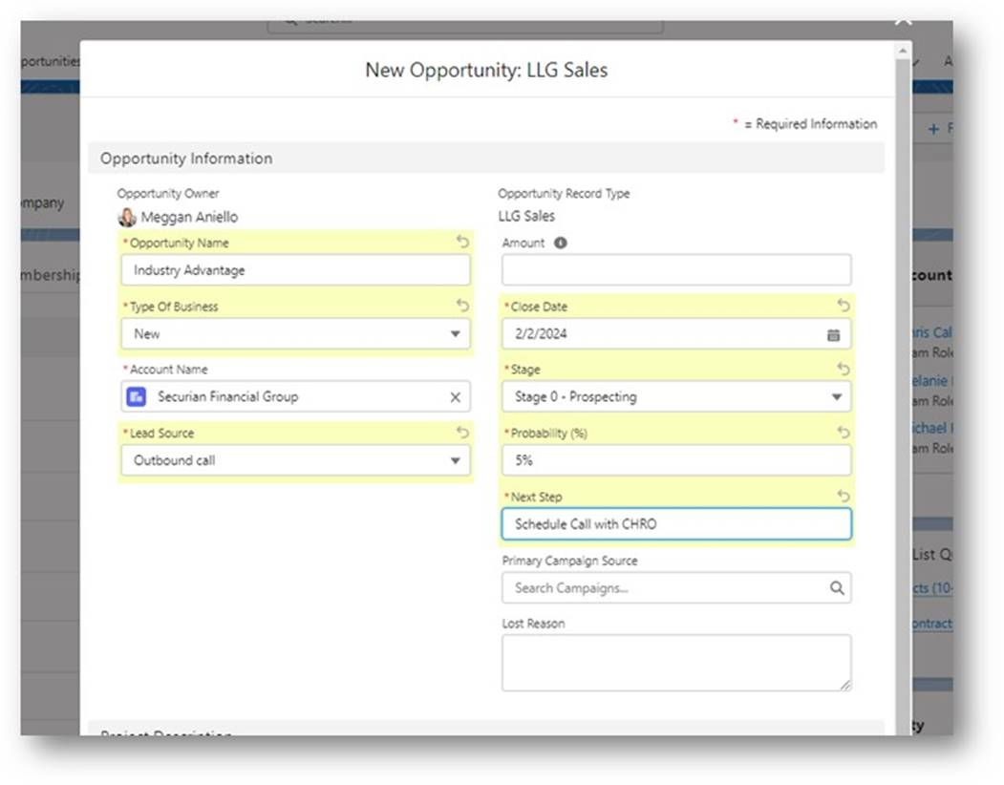

* On the Opportunity, add the **Opportunity Team** (Relationship Manager/MRD and Product Specialist/MSD)
* Add the **Product** (Product name shown below)

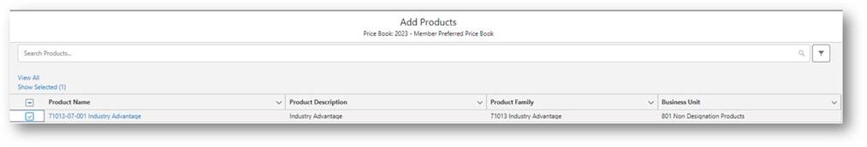

Page 1 of 2

* Add the **Contact Roles –** these are the external Contacts at the member, who you plan to engage with

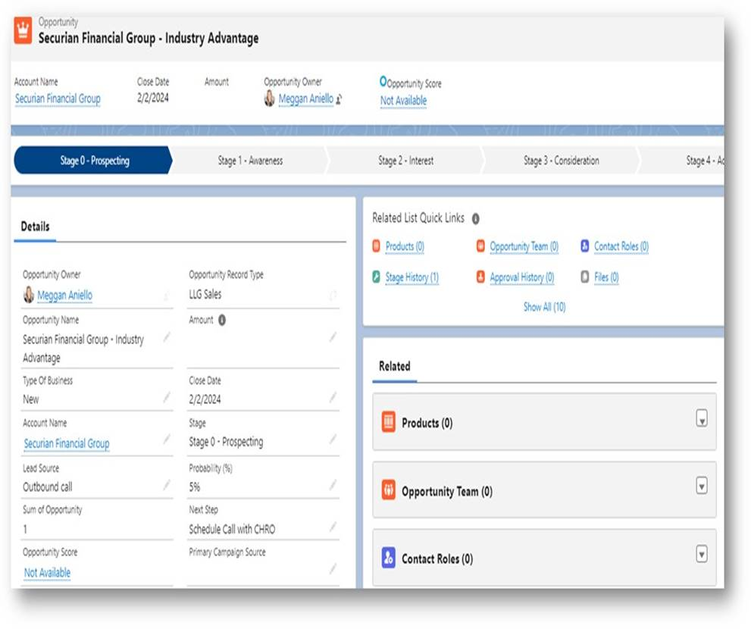

* Schedule your initial Conversation – ALL Activities should be associated/linked to the sales Opportunity – add all people you engage with to the Activity
* Once your first meeting takes place and you determine if you can/will continue to drive this Opportunity forward, move the Opportunity to **Stage 1 – Awareness** and beyond.

Page 2 of 2