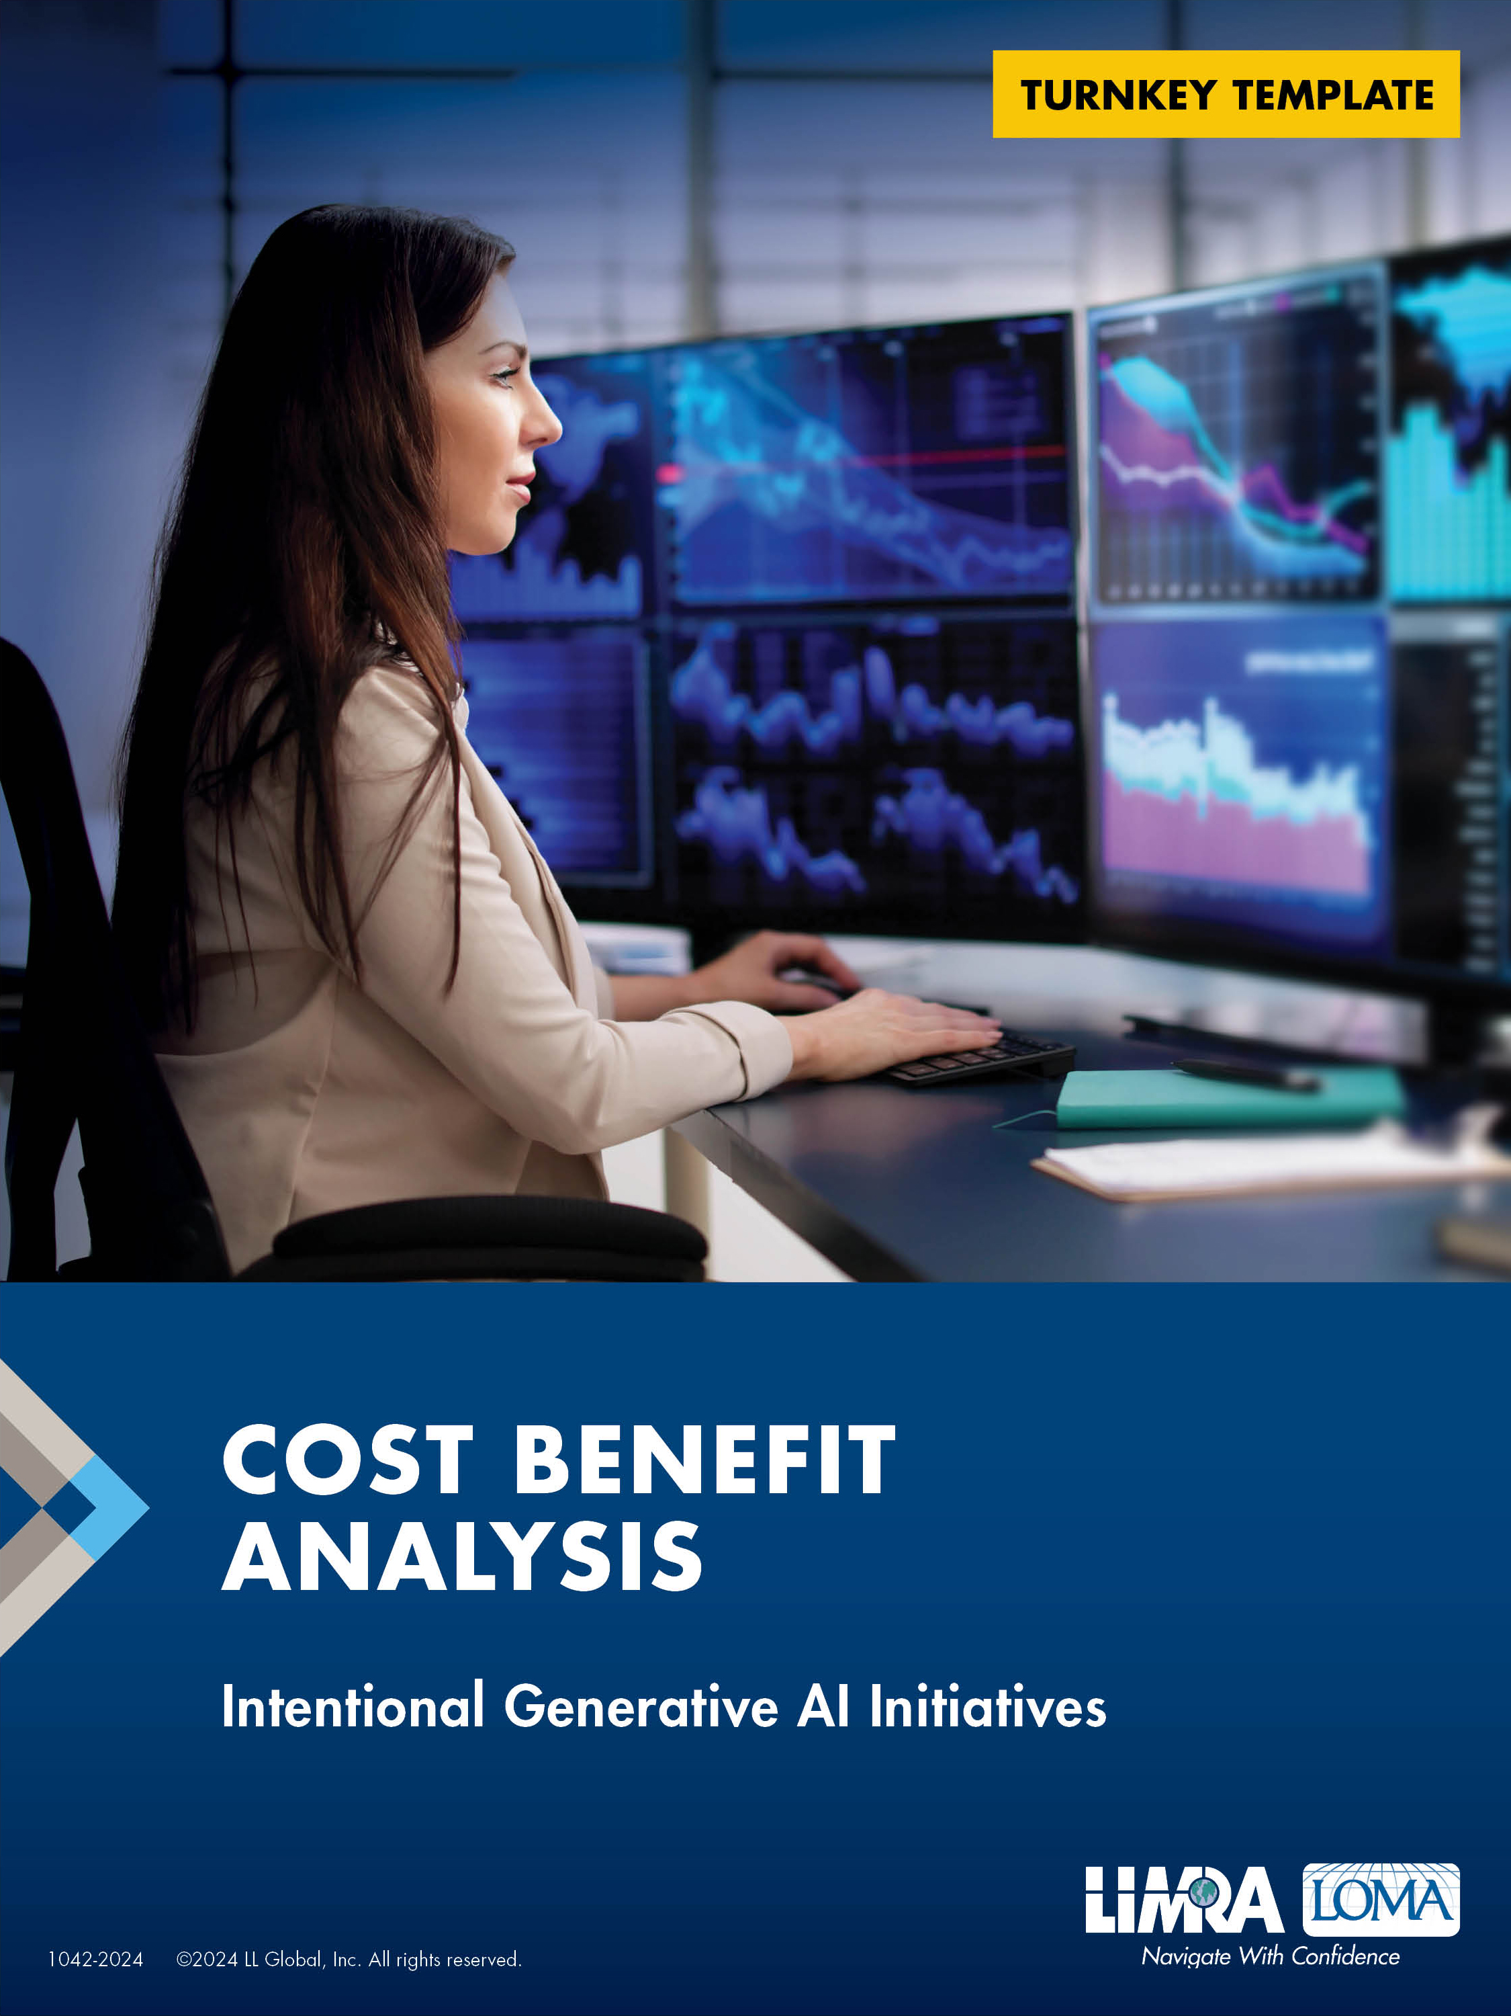

**For Additional Information:**

**Kartik Sakthivel, Ph.D., MS-IT/MS-CS, MBA, PGC-IQ**  
Vice President & Chief Information Officer   
LIMRA and LOMA  
[ksakthivel@limra.com](mailto:ksakthivel@limra.com)

*The frameworks and best practices provided herein are for general informational purposes and intended solely as guidelines to assist users in enhancing their AI strategies. These materials should not be construed as legal or financial advice or interpreted as setting a standard of care.  Users are encouraged to exercise their own discretion and judgment when applying these frameworks and best practices to their specific circumstances. While LL Global, Inc. (LIMRA and LOMA) strives to ensure the accuracy and completeness of the guidelines, LLG makes no guarantees regarding their effectiveness. Any reliance that users place on such materials is strictly at their own risk. Users are encouraged to consult with relevant professionals or experts before making any decisions based on these guidelines.*

# Overview

|  |  |
| --- | --- |
| **Date:** | <Enter submission date> |
| **Project Name:** | <Insert name of the project/initiative here> |
| **Project Code:** | <Provide an enterprise project code as appropriate> |
| **Lead:** | <Provide one Point of Contact/Project Manager/Program Manager/Scrum Master/Release Train Manager/Chief Scrum Master> |
| **Executive Summary:** | <Executive summary of the initiative. Remember to insert synopsis of final recommendations here> |
| **Executive Sponsor/s:** | <List of executive sponsors of the project/initiative> |
| **Description:** | <Provide a summary of the project> |

# 2.0 Expected Benefits

**Objective 1:** <Clearly define objectives (for ex: increase customer engagement, increase productivity, reduce content creation time, etc.)>

| Goal a: | <Clearly define measurable goals for each objective (for ex: increase customer engagement by x%, increase productivity by x%, reduce content creation time by x%)> |
| --- | --- |
| Goal b: |  |
| Goal c: |  |
| Goal n: |  |

**Objective 2:** <Clearly define objectives (for ex: increase customer engagement, increase productivity, reduce content creation time, etc.)>

|  |  |
| --- | --- |
| Goal a: | <Clearly define measurable goals for each objective (for ex: increase customer engagement by x%, increase productivity by x%, reduce content creation time by x%)> |
| Goal b: |  |
| Goal c: |  |
| Goal n: |  |

**Objective 3:** <Clearly define objectives (for ex: increase customer engagement, increase productivity, reduce content creation time, etc.)>

|  |  |
| --- | --- |
| Goal a: | <Clearly define measurable goals for each objective (for ex: increase customer engagement by x%, increase productivity by x%, reduce content creation time by x%)> |
| Goal b: |  |
| Goal c: |  |
| Goal n: |  |

**Objective n:** <Clearly define objectives (for ex: increase customer engagement, increase productivity, reduce content creation time, etc.)>

|  |  |
| --- | --- |
| Goal a: | <Clearly define measurable goals for each objective (for ex: increase customer engagement by x%, increase productivity by x%, reduce content creation time by x%)> |
| Goal b: |  |
| Goal c: |  |
| Goal n: |  |

# 3.0 Expected Costs

## 3.1 DIRECT COSTS:

### 3.1.1 Initial Investments:

|  |  |
| --- | --- |
| Subscription or Licensing Fees: | <Fees paid to the software vendor for using their GenAI solutions> |
| Usage and Transaction Costs: | <Costs incurred during training and testing from using APIs or transactions required by the GenAI solution, typically as number of credits or tokens> |
| Customization: | <Costs for customizing the GenAI solutions with existing software> |
| Integration: | <Costs for integrating the GenAI solutions with existing software> |
| Infrastructure: | <Infrastructure costs such as hardware, cloud services, and other infrastructure required to support new GenAI initiative> |
| Data Management: | <Costs for managing and storing data required for the GenAI solution> |
| Internal Data Preparation and Management Costs: | <Costs related to preparing enterprise data — if applicable — to be ingested into GenAI solution> |
| Implementation Consultant/s Costs: | <Third-party vendor or partner consulting fees> |
| Personnel Costs: | <Costs related to hiring employees to oversee the new GenAI solution> |
| Cybersecurity and Information Security: | <Costs for ensuring the GenAI solution meets cybersecurity and information security requirements> |
| Risk Management: | <Costs for ensuring the GenAI solution meets audit and compliance requirements> |
| Legal and Contracts: | <Costs associated with internal legal and contracting, typically as FTE costs> |
| Additional Costs a: | <Additional direct costs incurred by your organization> |
| Additional Costs b: | <Additional direct costs incurred by your organization> |
| Additional Costs n: | <Additional direct costs incurred by your organization> |
| **a. SUBTOTAL OF INITIAL COSTS** | $ |

### 3.1.2 Operationalization Costs (Implementation):

|  |  |
| --- | --- |
| Investment in Business Process Changes: | <One-time costs across the value chain, quantified in terms of FTE costs, that would be required to support reimagining or recreating business processes> |
| Change Management: | <One-time costs across the value chain, quantified in terms of FTE costs, that would be associated with enterprise change management to effectuate a cultural change by the use of the new GenAI solution> |
| Additional Costs a: | <Additional direct costs incurred by your organization for implementation of the new third-party vendor AI solution> |
| Additional Costs b: | <Additional direct costs incurred by your organization for implementation of the new third-party vendor AI solution> |
| **b. SUBTOTAL OF IMPLEMENTATION COSTS** | $ |

### 3.1.3 Operational Costs:

|  |  |
| --- | --- |
| Subscription or Licensing Fees: | <Ongoing fees paid to the software vendor for using their GenAI solutions> |
| Usage and Transaction Costs: | <Ongoing costs from using APIs or transactions required by the GenAI solution, typically as number of credits or tokens> |
| Infrastructure: | <Ongoing infrastructure costs such as hardware, cloud services, and other infrastructure required to support new GenAI initiative> |
| Data Management: | <Ongoing costs for managing data required for the GenAI solution> |
| Personnel Costs: | <Ongoing costs related to FTEs that oversee the new GenAI solution> |
| Cybersecurity and Information Security: | <Ongoing costs for ensuring the GenAI solution meets cybersecurity and information security requirements> |
| Risk Management: | <Ongoing costs for ensuring the GenAI solution meets audit and compliance requirements> |
| Maintenance and Support: | <Annual maintenance and support costs if separate from licensing costs> |
| Additional Costs a: | <Additional ongoing direct costs incurred by your organization> |
| Additional Costs b: | <Additional ongoing direct costs incurred by your organization> |
| Additional Costs n: | <Additional ongoing direct costs incurred by your organization> |
| **c. SUBTOTAL OF OPERATIONAL COSTS** | $ |

## 3.2 INDIRECT COSTS

|  |  |
| --- | --- |
| Opportunity Costs: | <Potential revenue or productivity lost while transitioning to use of new GenAI system, measured as estimated lost revenue or productivity during implementation — for ex: $xx in lost revenue during a 6m transition> |
| Downtime and Disruption Costs: | <Costs associated with any downtime or disruptions during the implementation phase, measured as estimated cost of downtime per hour/day — for ex: $xx/day for 5 days of downtime, totaling $xx> |
| Employee Productivity Loss: | <Temporary reduction in employee productivity as they learn and adapt to the new system, measured as the estimated loss in productivity per employee and overall – for ex: $xx/employee for n employees, totaling $xx> |
| Change Management: | <Indirect costs associated with managing the change process, including communication, planning, and support, measured as the total cost of change management activities — for ex: $xx for change management> |
| Compliance and Legal Costs: | <Initial costs for ensuring the GenAI solution complies with insurance industry regulations and legal requirements, measured by the initial compliance assessment and ongoing compliance monitoring costs – for ex: $xx for initial assessment> |
| Performance Monitoring Costs: | <Costs for monitoring and assessing the performance of the GenAI solution, measured by indirect costs performance monitoring tools and services> |
| Scaling Costs: | <Additional costs incurred when scaling the GenAI solution in order to handle increased usage or data, measured by the incremental cost for scaling up> |
| Vendor Management Costs: | <Costs for managing the relationship with the GenAI vendor, including contract negotiation and periodic reviews, quantified by time and resources allocated to vendor management> |
| Project Delay: | <Costs from potential delays in implementation of the GenAI solution> |
| Project Failure: | <Costs from potential that the GenAI solution does not deliver expected business results> |
| Additional Costs a: | <Additional ongoing indirect costs incurred by your organization> |
| Additional Costs b: | <Additional ongoing indirect costs incurred by your organization> |
| Additional Costs n: | <Additional ongoing indirect costs incurred by your organization> |
| **d. SUBTOTAL OF INDIRECT COSTS:** | $ |

|  |  |
| --- | --- |
| **TOTAL COSTS (a+b+c+d)** | **$** |

# 4.0 Expected Benefits

## 4.1 Direct Quantitative Benefits

|  |  |
| --- | --- |
| Productivity Increases: | <Time saved by automating tasks previously done manually> |
| Increase in Revenue: | <New sources of revenue or additional revenue from products/services enabled by GenAI solution> |
| Customer Satisfaction: | <Enhanced customer experience leading to higher satisfaction scores, measured as changes in the Net Promoter Score (NPS) and/or the Customer Satisfaction Score (CSAT)> |
| Cost Savings: | <Reduction in costs due to automation and efficiency improvements> |
| Cost Savings — Initial Capital Expenditure: | <Total initial costs avoided by not purchasing hardware, software, and infrastructure> |
| Cost Savings — Reduced Maintenance Costs: | <Annual savings on maintenance, updates, and support — for ex: $xx/year saved in IT maintenance and support costs> |
| Cost Savings — Lower IT Overhead: | <Reduction in IT staffing costs and resource allocation — for ex: $xx/year saved on IT staff salaries and related costs> |
| Cost Savings — Training Costs: | <Cost savings on training programs and time spent on upskilling – for ex: $xx/year saved on training and development> |
| Error Reduction: | <Fewer human errors due to automation, measured as a decrease in error rate percentage — for ex: n% reduction in error, x% improvement in quality, resulting in $xx saved by avoiding rework> |
| Additional Benefits a: | <Additional ongoing benefits incurred by your organization> |
| Additional Benefits b: | <Additional ongoing benefits incurred by your organization> |
| Additional Benefits n: | <Additional ongoing benefits incurred by your organization> |
| **a. SUBTOTAL OF DIRECT BENEFITS:** | **$** |

**4.2 Qualitative Benefits**

|  |  |
| --- | --- |
| Employee Satisfaction: | <Reduced workload due to time saved by automating routine tasks — for ex: xx hours/year saved, equivalent to $xx/year> |
| Enterprise Institutional Knowledge: | <Better utilization of organizational knowledge due to GenAI solutions, measured as time saved by FTEs in being able to find and use appropriate information> |
| Productivity: | <Employee engagement and productivity improvements — for ex: n% productivity increase, valued at $xx/year> |
| Competitive Edge: | <Market share growth due to faster adoption of new technologies — for ex: n% market share increase, valued at $xx/year> |
| Innovation and Competitive Advantage: | <Increased innovation and speed to market for new products. Time-to-market for new innovations — for ex: innovation cycle will be 6 months faster due to third-party vendor> |
| Cross-Enterprise Collaboration: | <Improvement in team collaboration across the value chain — for ex: n% increase in collaboration efficiency, valued at $xx/year> |
| Additional Benefits a: | <Additional ongoing benefits incurred by your organization> |
| Additional Benefits b: | <Additional ongoing benefits incurred by your organization> |
| Additional Benefits n: | <Additional ongoing benefits incurred by your organization> |
| **b. SUBTOTAL OF QUALITATIVE BENEFITS:** | **$** |

|  |  |
| --- | --- |
| **TOTAL BENEFITS (a+b)** | **$** |

# 5. Risks and Mitigation

## 5.1 Technical Risks and Mitigation

|  |  |  |  |  |
| --- | --- | --- | --- | --- |
|  | RISK | MITIGATION | PROBABILITY  OF OCCURRENCE (%) | POTENTIAL IMPACT COST ($) |
| 1 | Data quality |  |  |  |
| 2 | Performance |  |  |  |
| 3 | Reliability |  |  |  |
| n | <Insert additional risks> |  |  |  |

1. **Contingency Budget for Technical Risk Management:** $xx

## 5.2 Operational Risks and Mitigation

|  |  |  |  |  |
| --- | --- | --- | --- | --- |
|  | RISK | MITIGATION | PROBABILITY  OF OCCURRENCE (%) | POTENTIAL IMPACT COST ($) |
| 1 | Integration challenges |  |  |  |
| 2 | Disruption of existing business processes |  |  |  |
| n | <Insert additional risks> |  |  |  |

1. **Contingency Budget for Operational Risk Management:** $xx

## 5.3 Financial Risks and Mitigation

|  |  |  |  |  |
| --- | --- | --- | --- | --- |
|  | RISK | MITIGATION | PROBABILITY  OF OCCURRENCE (%) | POTENTIAL IMPACT COST ($) |
| 1 |  |  |  |  |
| 2 |  |  |  |  |
| 3 |  |  |  |  |
| n | <Insert additional risks> |  |  |  |

1. **Contingency Budget for Financial Risk Management:** $xx

## 5.4 Compliance Risks and Mitigation

|  |  |  |  |  |
| --- | --- | --- | --- | --- |
|  | RISK | MITIGATION | PROBABILITY  OF OCCURRENCE (%) | POTENTIAL IMPACT COST ($) |
| 1 |  |  |  |  |
| 2 |  |  |  |  |
| 3 |  |  |  |  |
| n | <Insert additional risks> |  |  |  |

1. **Contingency Budget for Compliance Risk Management:** $xx

**Total Contingency Budget for Risk Management:** $xx <SUM a through d, add others as appropriate to your firm>

# 6. Total Costs and Benefits

|  |  |
| --- | --- |
| TOTAL OF ANTICIPATED COSTS | $xx |
| TOTAL OF EXPECTED BENEFITS | $xx |

# 7. Outlook

|  |  |  |
| --- | --- | --- |
| Time Span | Benefits | Costs |
| Short-Term (<1 year) |  |  |
| Medium-Term (1 – 3 years) |  |  |
| Long-Term (3+ years) |  |  |

# 8. Net Present Value

|  |  |  |  |  |
| --- | --- | --- | --- | --- |
| Time Period (t) | Benefits ($) | Costs ($) | Net Benefits ($) | Present Value ($) |
| Year 1 |  |  |  |  |
| Year 2 |  |  |  |  |
| Year 3 |  |  |  |  |
| ... |  |  |  |  |

# 9. Sensitivity **Analysis**

|  |  |  |
| --- | --- | --- |
| Scenario | NPV ($) | Key Assumptions |
| Best-Case |  |  |
| Worst-Case |  |  |
| Most Likely |  |  |

# 10. Decision Summary

|  |  |
| --- | --- |
| Recommendation | |
| Proceed With Project |  |
| Revise and Reassess |  |
| Do not Proceed |  |

