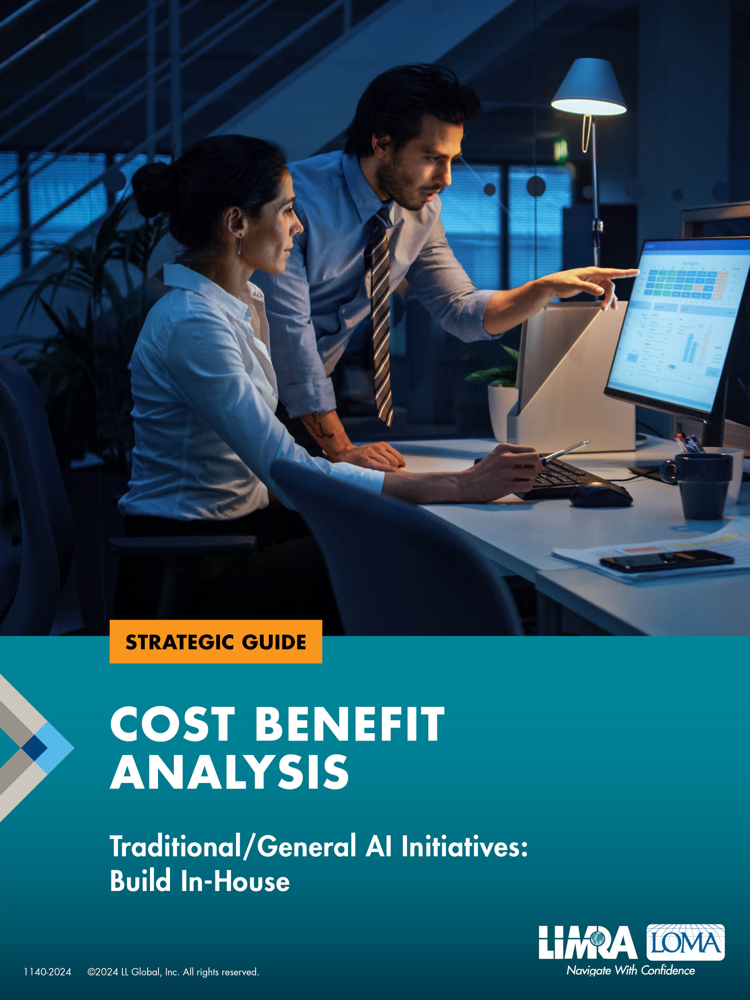

**For Additional Information:**

**Kartik Sakthivel, Ph.D., MS-IT/MS-CS, MBA, PGC-IQ**  
Vice President & Chief Information Officer   
LIMRA and LOMA  
[ksakthivel@limra.com](mailto:ksakthivel@limra.com)

*The frameworks and best practices provided herein are for general informational purposes and intended solely as guidelines to assist users in enhancing their AI strategies. These materials should not be construed as legal or financial advice or interpreted as setting a standard of care.  Users are encouraged to exercise their own discretion and judgment when applying these frameworks and best practices to their specific circumstances. While LL Global, Inc. (LIMRA and LOMA) strives to ensure the accuracy and completeness of the guidelines, LLG makes no guarantees regarding their effectiveness. Any reliance that users place on such materials is strictly at their own risk. Users are encouraged to consult with relevant professionals or experts before making any decisions based on these guidelines.*

# Overview

**Date:** <Enter submission date>

**Project Name:** <Insert name of the project/initiative here>

**Project Code:** <Provide an enterprise project code as appropriate>

**Lead:** <Provide one Point of Contact/Project Manager/Program Manager/Scrum Master/Release Train Manager/Chief Scrum Master>

**Executive Summary:** <Executive summary of the initiative. Remember to insert synopsis of final recommendations here>

**Executive Sponsor/s:** <List of executive sponsors of the project/initiative>

**Description:** <Provide a summary of the project>

# 2.0 Expected Benefits

**Objective 1:** <Clearly define objectives (for ex: increase customer engagement, increase productivity, reduce content creation time, etc.)>

* Goal a: <Clearly define measurable goals for each objective (for ex: increase customer engagement by x%, increase productivity by x%, reduce content creation time by x%)>
* Goal b:
* Goal c:
* …
* ….
* …..
* Goal n

**Objective 2:**

**Objective 3:**

…

…..

……

**Objective n:**

# 3.0 Expected Costs

## 3.1 DIRECT COSTS:

### 3.1.1 Initial Investments:

* Development Costs: <Initial development costs related to developing the AI solution, including software development, algorithm creation, and testing, measured as total development costs over the timeline of the project>
* Infrastructure Costs: <Initial costs for hardware, cloud services, and other infrastructure needed to support AI development and deployment>
* Salaries and Benefits: <Costs for FTEs across the value chain involved in the project>
* Talent Acquisition: <Costs for hiring and retaining skilled AI professionals, such as data scientists, AI engineers, and developers>
* Training and Development: <Costs for continuous training and development of employees involved in the initiative in order to keep up with the latest AI advancements and methodologies>
* Data Acquisition: <Costs for acquiring appropriate data from external third-party vendors>
* Data Management: <Costs for cleaning, managing, and storing data necessary for training in-house developed AI model>
* Software Licenses and Tooling: <Costs for software licenses, development tools, and other necessary software components>
* Cybersecurity Requirements: <Costs to ensure the in-house developed AI system meets cybersecurity and information security requirements>
* Audit: <Costs to conduct audits of AI system, internal audit costs in terms of FTE and dollar amounts for external third-party model validation>
* Quality Assurance and Quality Control: <Costs to conduct quality assurance and quality control of model to ensure and attest to model efficacy, internal QA and QC costs in terms of FTE and dollar costs for external third-party model testing>
* Additional Costs a: <Additional direct costs incurred by your organization>
* Additional Costs b:
* …
* …..
* …….
* Additional Costs n:

**a. SUBTOTAL OF INITIAL COSTS: $**

### 3.1.2 Operationalization Costs (Implementation):

* Investment in Business Process Changes: <One-time costs across the value chain, quantified in terms of FTE costs, that would be required to support reimagining or recreating business processes>
* Change Management: <One-time costs across the value chain, quantified in terms of FTE costs, that would be associated with enterprise change management to effectuate a cultural change by the use of the new AI solution>
* Risk Management and Compliance: <Costs to ensure the AI system meets compliance requirements, including audits and certifications>
* Additional Costs a: <Additional direct costs incurred by your organization for implementation of the new in-house built AI solution >
* Additional Costs b:
* …
* …..
* …….
* Additional Costs n:

**b. SUBTOTAL OF IMPLEMENTATION COSTS: $**

### 3.1.3 Operational Costs:

* Software as a Service (SaaS) Licensing Fees: <Annual/monthly licensing/subscription costs for any software products being leveraged within the project>
* Maintenance and Support: <Ongoing costs for maintaining and supporting the in-house AI solution, including model fixes and updates >
* Additional Data Management Costs: <Ongoing costs associated with additional third-party data sets for consumption in in-house built model; costs for data collection, cleaning, and storage>
* Internal Infrastructure Costs: <Ongoing internal infrastructure costs such as hardware, cloud services, and other infrastructure required to support new initiative>
* Risk Management: <Ongoing audit and compliance costs, quantified in terms of FTE costs and/or tools and/or business process changes >
* Data Privacy and Information Security: <Ongoing costs associated with compliance with data privacy regulation or guidelines and information security>
* Cybersecurity: <Ongoing costs associated with updated cybersecurity needs for protecting AI solution>
* Updates: <Recurring costs for updating the AI solution to meet evolving business requirements>
* Compliance and Legal Costs: <Ongoing costs for ensuring the AI solution complies with insurance industry regulations and legal requirements, measured by the initial compliance assessment and ongoing compliance monitoring costs — for ex: $xx for initial assessment>
* Training and Development: <Ongoing costs for continuous training and development of employees involved in the initiative in order to keep up with the latest AI advancements and methodologies>
* Additional Costs a: <Additional ongoing direct costs incurred by your organization>
* Additional Costs b:
* …
* …..
* …….
* Additional Costs n:

**c. SUBTOTAL OF OPERATIONAL COSTS: $**

## 3.2 INDIRECT COSTS

* Opportunity Costs: <Potential revenue or productivity lost while focusing resources on building the AI solution, measured as estimated lost revenue or productivity>
* Downtime and Disruption: <Costs associated with any downtime or disruptions during the AI system’s development and deployment, measured as the estimated cost of downtime per hour/day>
* Loss of Productivity: <Temporary reduction in employee productivity as they learn and adapt to the new AI system measured as the estimated loss of productivity per employee>
* Change Management: <Costs associated with managing the change process, including communication, planning, and support>
* Risk of Delays and Overruns: <Potential costs from delays in project timelines and missed deadlines, measured as the estimated cost of project delays>
* Risk of Project Failure: <Potential costs if the AI project fails to deliver expected results, measured as the estimated sunk costs of failure>
* Internal Coordination and Collaboration: <Costs associated with internal collaboration and coordination across departments in the value chain>
* Training Costs: <Costs for training new employees on the AI system>
* Knowledge Transfer: <Costs for transferring knowledge of new AI system across the value chain, or from construction to operationalization>
* Ecosystem Integration: <Costs for integrating the AI solution with existing IT systems and infrastructure>
* Business Process Changes: <Costs for business process changes commensurate to new AI system across the value chain>
* Intellectual Property: <Costs for managing and protecting intellectual property developed in-house, measured as the annual cost of IP management>
* Additional Costs a: <Additional ongoing indirect costs incurred by your organization>
* Additional Costs b:
* …
* …..
* …….
* Additional Costs n:

**d. SUBTOTAL OF INDIRECT COSTS: $**

|  |  |
| --- | --- |
| **TOTAL COSTS (a+b+c+d)** | **$** |

# 4.0 Expected Benefits

## 4.1 Direct Quantitative Benefits

* Customization: <Complete control of AI system’s functionality, created bespoke to meet business requirements, measured as a percentage of alignment to business needs, valued at $xx/annually in operational efficiency>
* Adaptability: < Time saved adapting the solution to changing business requirements — for ex: n months faster adaptability, valued at $xx/annually>
* Cost Savings: <Annual savings from not having to pay subscription/licensing fees>
* Reduced Total Cost of Ownership (TCO): <Comparison of TCO over a period of years versus vendor solutions>
* Intellectual Property Control: <Benefits of retaining IP rights, measured as the value of intellectual property created, for ex — $xx in IP value, potentially more if AI solution is patented or commercialized>
* Commercialization Opportunities: <Revenue from licensing or selling the AI solution to other firms in the insurance ecosystem>
* Data and Information Security: <Complete control over data used for AI models, potentially resulting in reduction in data breaches>
* Cybersecurity: <Leveraging existing corporate cybersecurity practices, measured as the cost of implementing tailored security solutions and quantified as $xx in enhanced security value>
* Ecosystem Integration: <Time and cost savings from seamless integration with existing systems>
* Operational Efficiency: <Efficiency gains that result from better-integrated systems, measured in terms of n% increase in operational efficiency, valued at $xx>
* Additional Benefits a: <Additional ongoing benefits incurred by your organization>
* Additional Benefits b:
* …
* …..
* …….
* Additional Benefits n:

**a. SUBTOTAL OF DIRECT BENEFITS: $**

## 4.2 Qualitative Benefits

* Strategic Alignment: <Tailored to enterprise business strategy, the degree of alignment with long-term strategic goals — for ex: n% improvement in strategic goal achievement, valued at $xx/year.
* Innovation: <Measured by the number of innovative features developed in-house — for ex: n new features developed, contributing $xx/year in competitive advantage>
* Market Differentiation: <Market share growth due to unique AI capabilities — for ex: n% market share increase, valued at $xx/year>
* Employee Skill Development: <Improvement in employee skills and expertise, measured as the amount equivalent to $xx/year in training value>
* Increased Job Satisfaction: <Employee satisfaction scores measured by Employee Net Promoter Score (eNPS) and retention rates — for ex: n% increase in satisfaction and n% increase in retention, valued at $xx/year>
* Cultural of Innovation: <Improvement in organizational innovation culture — for ex: n% increase in innovation initiatives, valued at $xx/year>
* Internal Collaboration: <Enhanced collaboration across departments — for ex: n% increase in collaboration efficiency, valued at $xx/year>
* Sustainable Competitive Advantage: <Long-term benefits from sustained competitive advantage — for ex: equivalent to $250,000/year in strategic value>
* Business Continuity: <Improved business continuity and resilience — for ex: n% reduction in downtime, valued at $xx/year>
* Institutional Knowledge: <Value of retained and transferred knowledge — for ex: equivalent to $100,000/year in training and knowledge transfer>
* Stakeholder Confidence: <Increased trust and improvement in stakeholder confidence — for ex: n% improvement in trust, contributing to $xx/year in value>
* Customer Experience: <Improvement in customer satisfaction measured by Net Promoter Score (NPS) or Pulse Surveys and retention — for ex: n% increase in customer satisfaction and n% increase in retention, valued at $xx/year>
* Futureproofing: <Ability to remain ahead of technological advancements — for ex: equivalent to $150,000/year in strategic value>
* Additional Benefits a: <Additional ongoing benefits incurred by your organization>
* Additional Benefits b:
* …
* …..
* …….
* Additional Benefits n:

**b. SUBTOTAL OF QUALITATIVE BENEFITS: $**

|  |  |
| --- | --- |
| **TOTAL BENEFITS (a+b)** | **$** |

# 5. Risks and Mitigation

## 5.1 Technical Risks and Mitigation

|  |  |  |  |  |
| --- | --- | --- | --- | --- |
|  | RISK | MITIGATION | PROBABILITY  OF OCCURRENCE (%) | POTENTIAL IMPACT COST ($) |
| 1 | Data quality |  |  |  |
| 2 | Performance |  |  |  |
| 3 | Reliability |  |  |  |
| n | <Insert additional risks> |  |  |  |

1. **Contingency Budget for Technical Risk Management:** $xx

## 5.2 Operational Risks and Mitigation

|  |  |  |  |  |
| --- | --- | --- | --- | --- |
|  | RISK | MITIGATION | PROBABILITY  OF OCCURRENCE (%) | POTENTIAL IMPACT COST ($) |
| 1 | Integration challenges |  |  |  |
| 2 | Disruption of existing business processes |  |  |  |
| n | <Insert additional risks> |  |  |  |

1. **Contingency Budget for Operational Risk Management:** $xx

## 5.3 Financial Risks and Mitigation

|  |  |  |  |  |
| --- | --- | --- | --- | --- |
|  | RISK | MITIGATION | PROBABILITY  OF OCCURRENCE (%) | POTENTIAL IMPACT COST ($) |
| 1 |  |  |  |  |
| 2 |  |  |  |  |
| 3 |  |  |  |  |
| n | <Insert additional risks> |  |  |  |

1. **Contingency Budget for Financial Risk Management:** $xx

## 5.4 Compliance Risks and Mitigation

|  |  |  |  |  |
| --- | --- | --- | --- | --- |
|  | RISK | MITIGATION | PROBABILITY  OF OCCURRENCE (%) | POTENTIAL IMPACT COST ($) |
| 1 |  |  |  |  |
| 2 |  |  |  |  |
| 3 |  |  |  |  |
| n | <Insert additional risks> |  |  |  |

1. **Contingency Budget for Compliance Risk Management:** $xx

**Total Contingency Budget for Risk Management:** $xx <SUM a through d, add others as appropriate to your firm>

# 6. Total Costs and Benefits

|  |  |
| --- | --- |
| TOTAL OF ANTICIPATED COSTS | $xx |
| TOTAL OF EXPECTED BENEFITS | $xx |

# 7. Outlook

|  |  |  |
| --- | --- | --- |
| Time Span | Benefits | Costs |
| Short-Term (<1 year) |  |  |
| Medium-Term (1 – 3 years) |  |  |
| Long-Term (3+ years) |  |  |

# 8. Net Present Value

|  |  |  |  |  |
| --- | --- | --- | --- | --- |
| Time Period (t) | Benefits ($) | Costs ($) | Net Benefits ($) | Present Value ($) |
| Year 1 |  |  |  |  |
| Year 2 |  |  |  |  |
| Year 3 |  |  |  |  |
| ... |  |  |  |  |

# 9. Sensitivity **Analysis**

|  |  |  |
| --- | --- | --- |
| Scenario | NPV ($) | Key Assumptions |
| Best-Case |  |  |
| Worst-Case |  |  |
| Most Likely |  |  |

# 10. Decision Summary

|  |  |
| --- | --- |
| Recommendation | |
| Proceed With Project |  |
| Revise and Reassess |  |
| Do not Proceed |  |

